**Assignment 5 – Data Story**

Sai Pravallitha Vemireddy

MS Information Technology and Management

sxv210097

**Section 1:**

Screenshots of all the relationships:

* orders.csv - order_products.csv relationship:

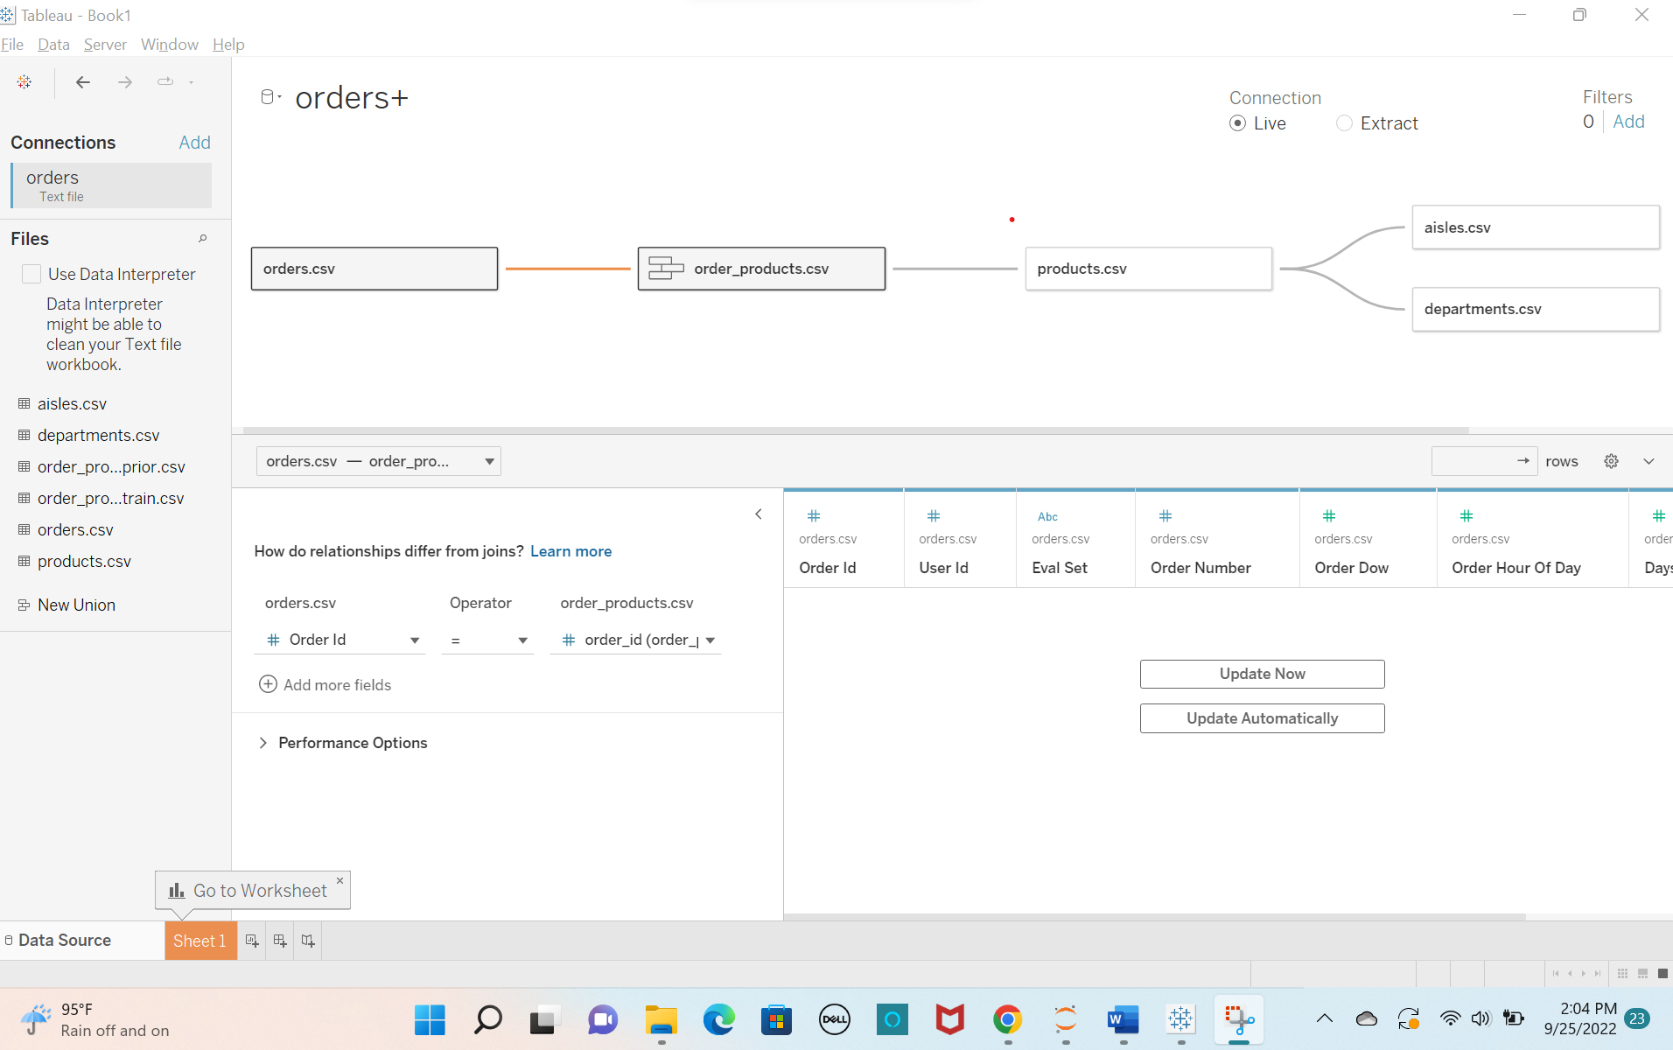

* order_products.csv - products.csv relationship:

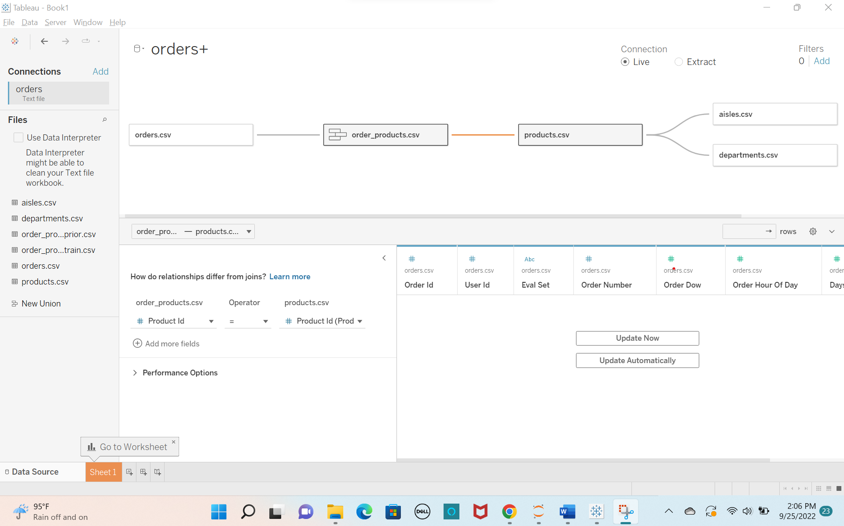

* products.csv – aisles.csv relationship:

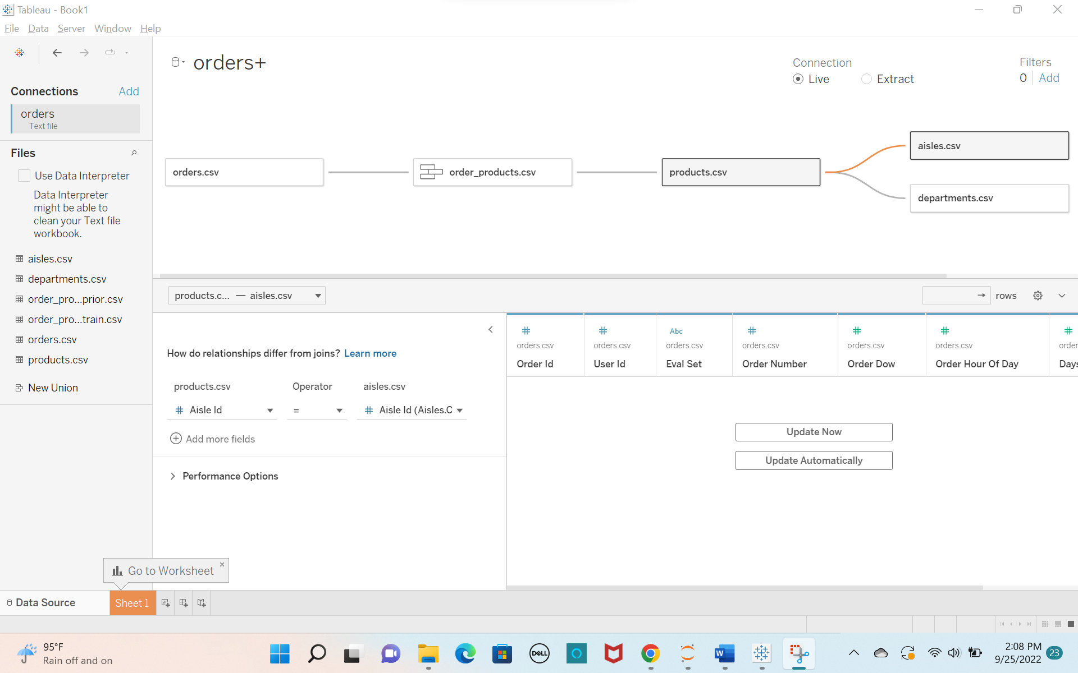

* products.csv – departments.csv relationship:

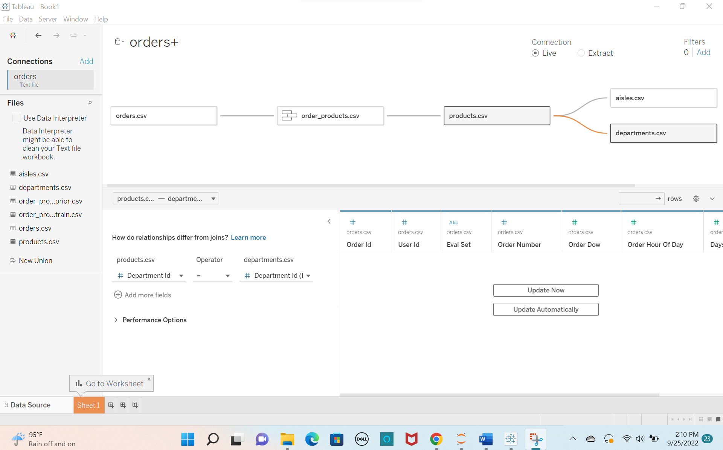

**Section 2:**

**Question:** What are the primary groups and individuals that are the focus of your communication?

**Answer:** Following are the primary groups and individuals that are focus of my communication:

* Instacart product suppliers
* Instacart customers
* Instacart competitor’s customers
* Instacart developers
* Instacart social media (Facebook, Instagram)
* Employees and Employers of Instacart (Staff, IT department, HR department, Sales, Finance, Marketing, CEO, Founders, Co-founders, Directors)

**Question:** List the executive role or position that is the key decision maker in your audience?

**Answer:** CEO, Directors and Top Managers are the key decision makers in my audience.

**Question:** How much experience does your audience have working with this data? (Shallow or deep; include at least one defining sentence of justification)

**Answer:** My audience have deep experience to work on this data as they are integral part of Instacart and have been working on this since long time.

**Question:** What is the scope of your audience? (Wide or narrow; include at least one defining sentence of justification)

**Answer:** Scope of my audience is narrow as they mainly focus on grocery products which are handled by Instacart, and they are affected in one or the other way by Instacart decisions.

**Question:** What does your audience care about? (You can circle back to this question after your analysis)

**Answer:** My audience care about getting more customers, making the ordering process easy on Instacart, generating more revenue, and increasing orders count in less time.

**Question:** What action does your audience need to take? (You can circle back to this question after your analysis)

**Answer:** Action to be taken by my audience – increasing count of orders, providing best customer experience during all times like busiest hours, improving Instacart website/application user experience by adding attractive user interface, and providing speed delivery option.

**Question:** What are the stakes? (What matters, what is the point)

**Answer:** Stakes are the weighted outcomes of the decisions that our audience take. If my audience act in the way I want, the benefits are - getting profits to Instacart, making customers happy or attracting competitors’ customers, reduced time between orders and increasing the orders per hour. If my audience are not acting the way I want, then the stakes are risk of reputation, losing to competitors, revenue loss, and waste of resources.

**Question:** What is the big idea? (This will form the main storyline)

**Answer:** Providing the customers with best e-commerce website/application experience and focusing on customer satisfaction along with increasing revenue!

**Section 3:**

**1. Service Analysis:**

**a)**

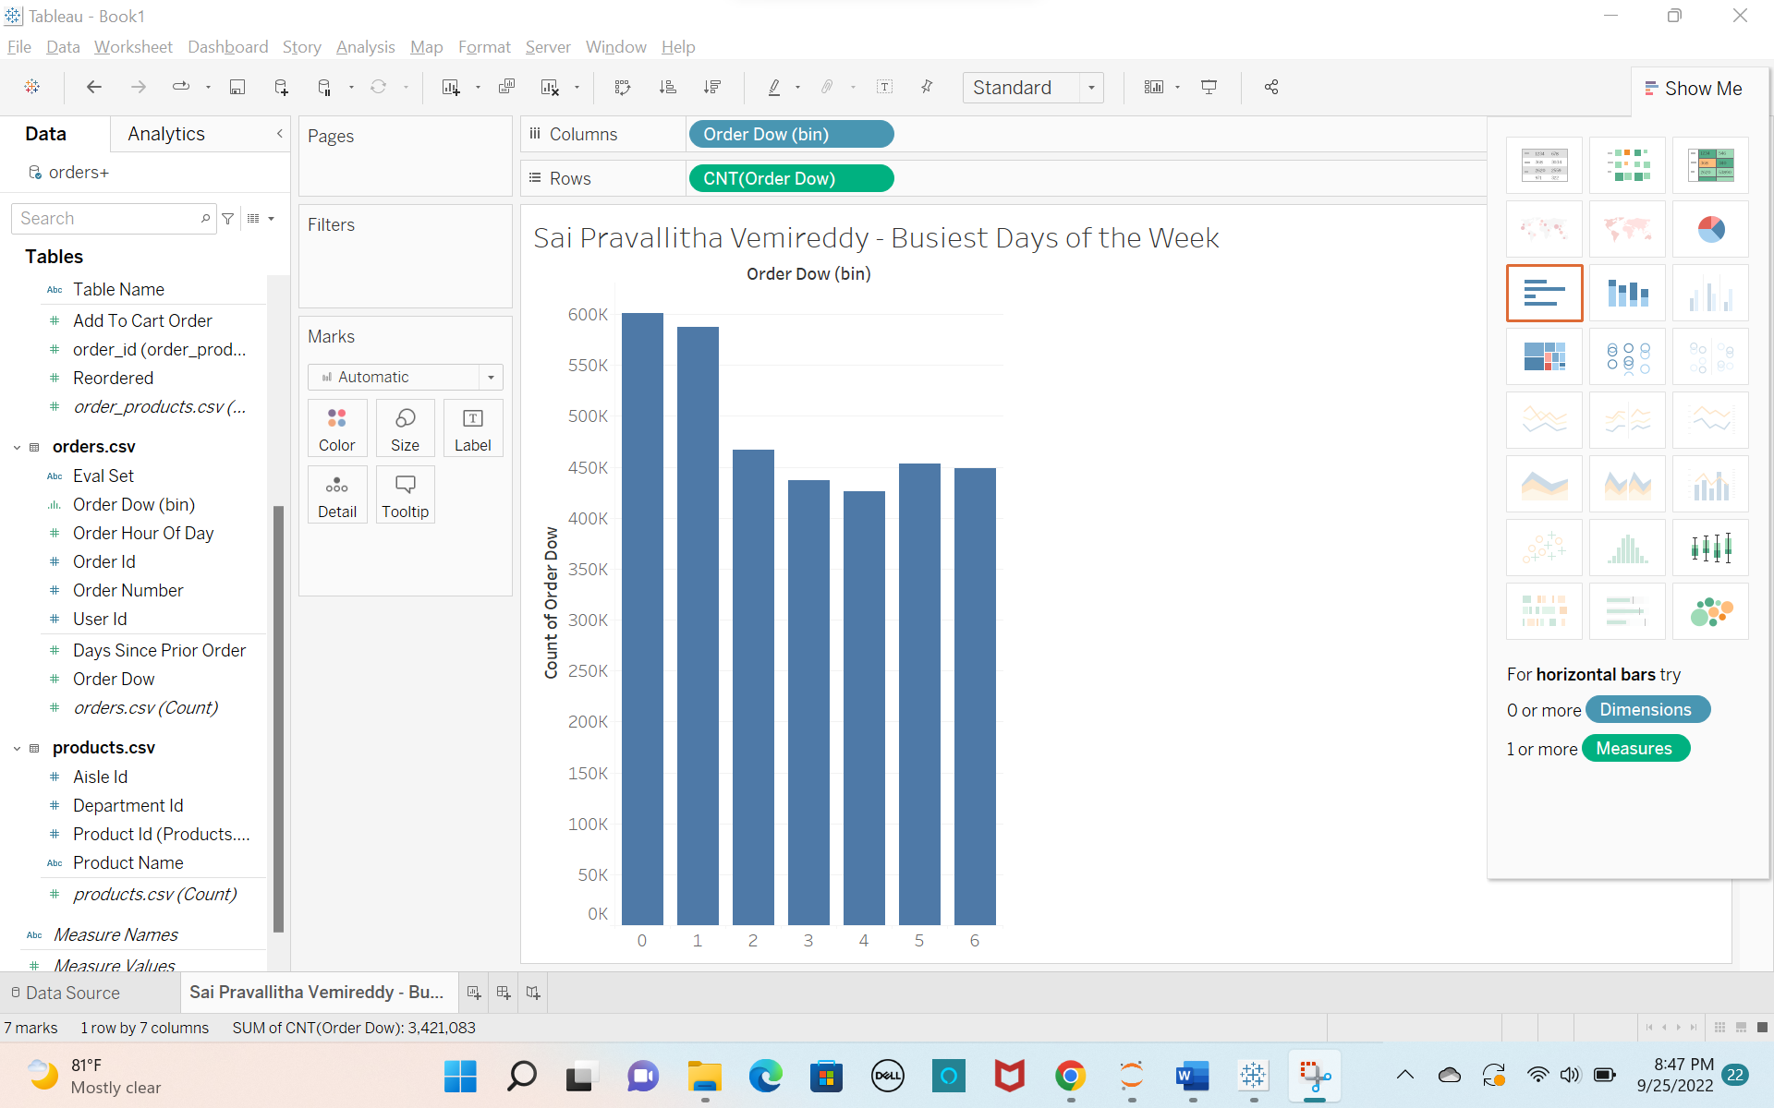

**Question 1:**

0 and 1 are the two busiest days of the week.

**b)**

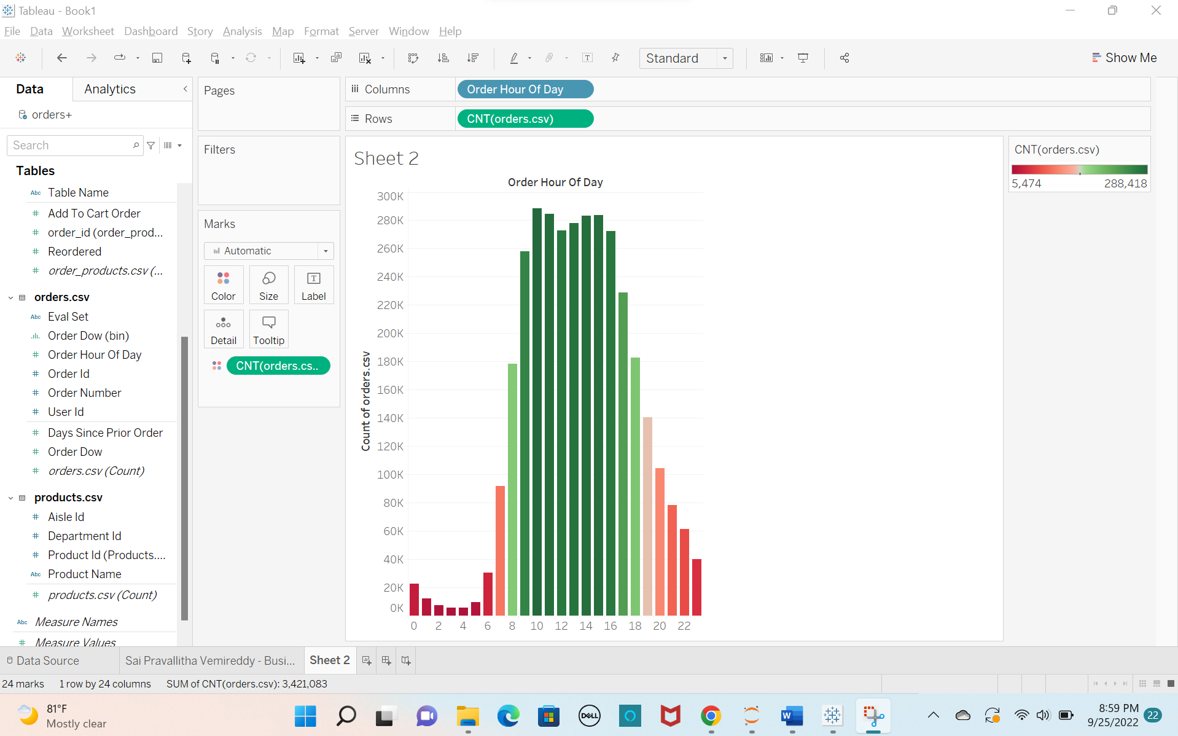

**Question 2:**

Top 11 busiest hours are:

In descending order: 10, 11, 15, 14, 13, 12, 16, 9, 17, 18, 8

**Busiest hours for each day of the week:**

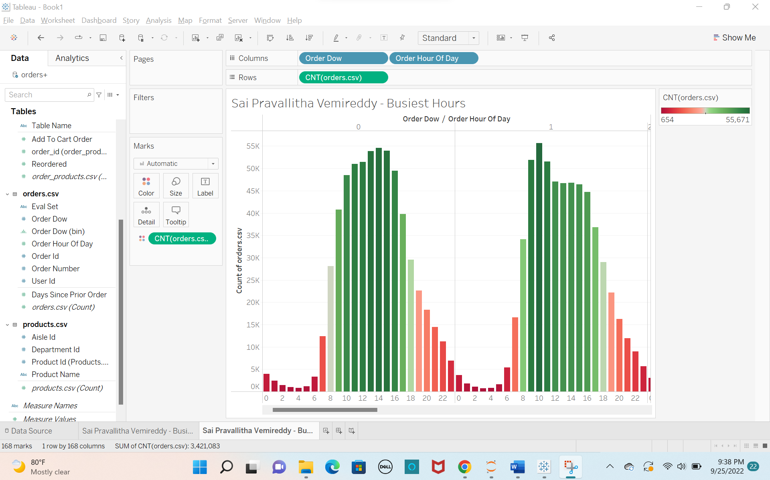

**c)**

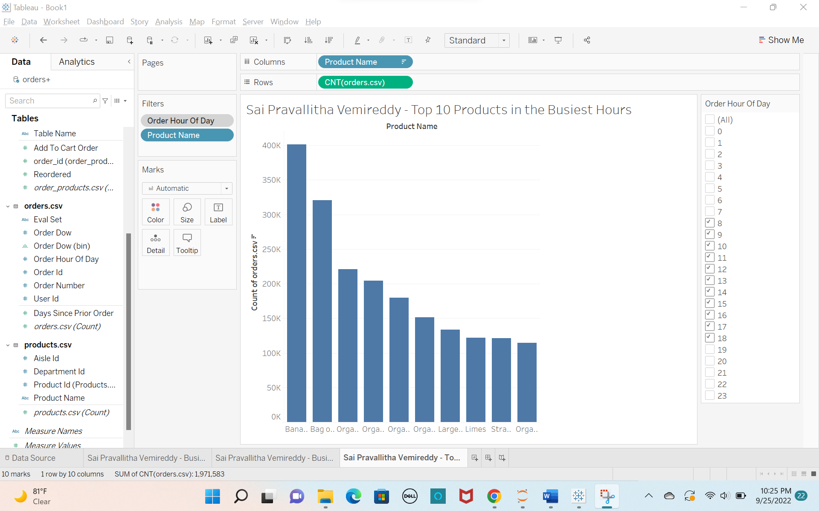

**Question 3:**

Banana is the most sold product during the busiest hours.

**d)**

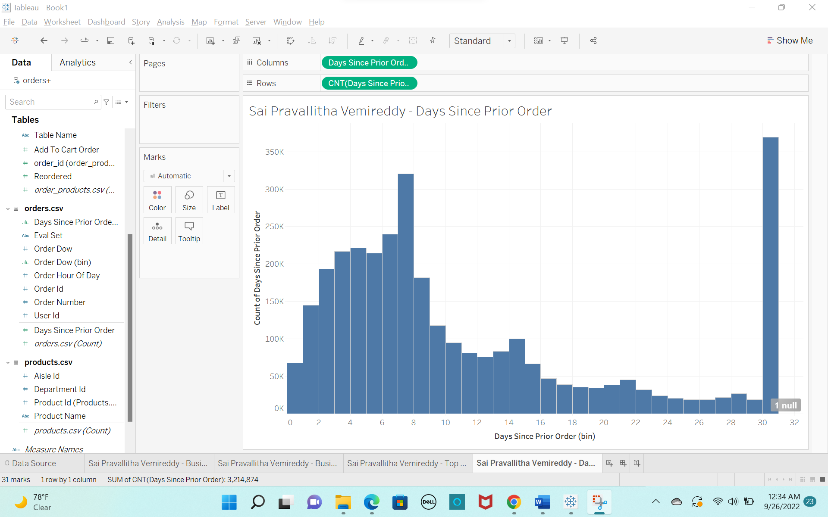

**Question 4:**

Customers most likely to order again: 30 days since prior order

**2. Product Analysis:**

**a)**

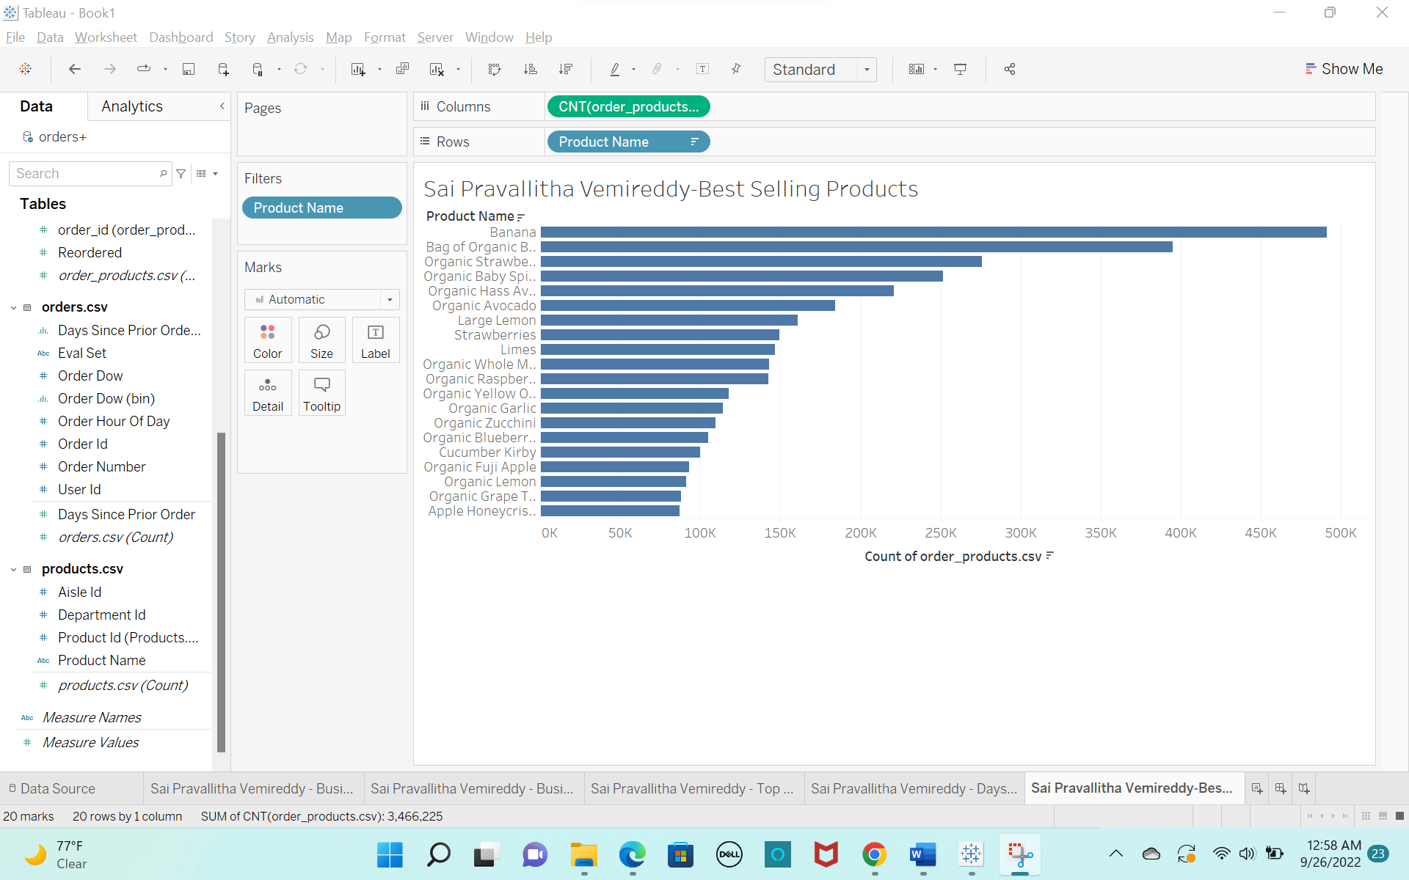

**Question 5:**

Top 3 bestselling products: Banana, Bag of Organic Bananas, Organic Strawberries

**b)**

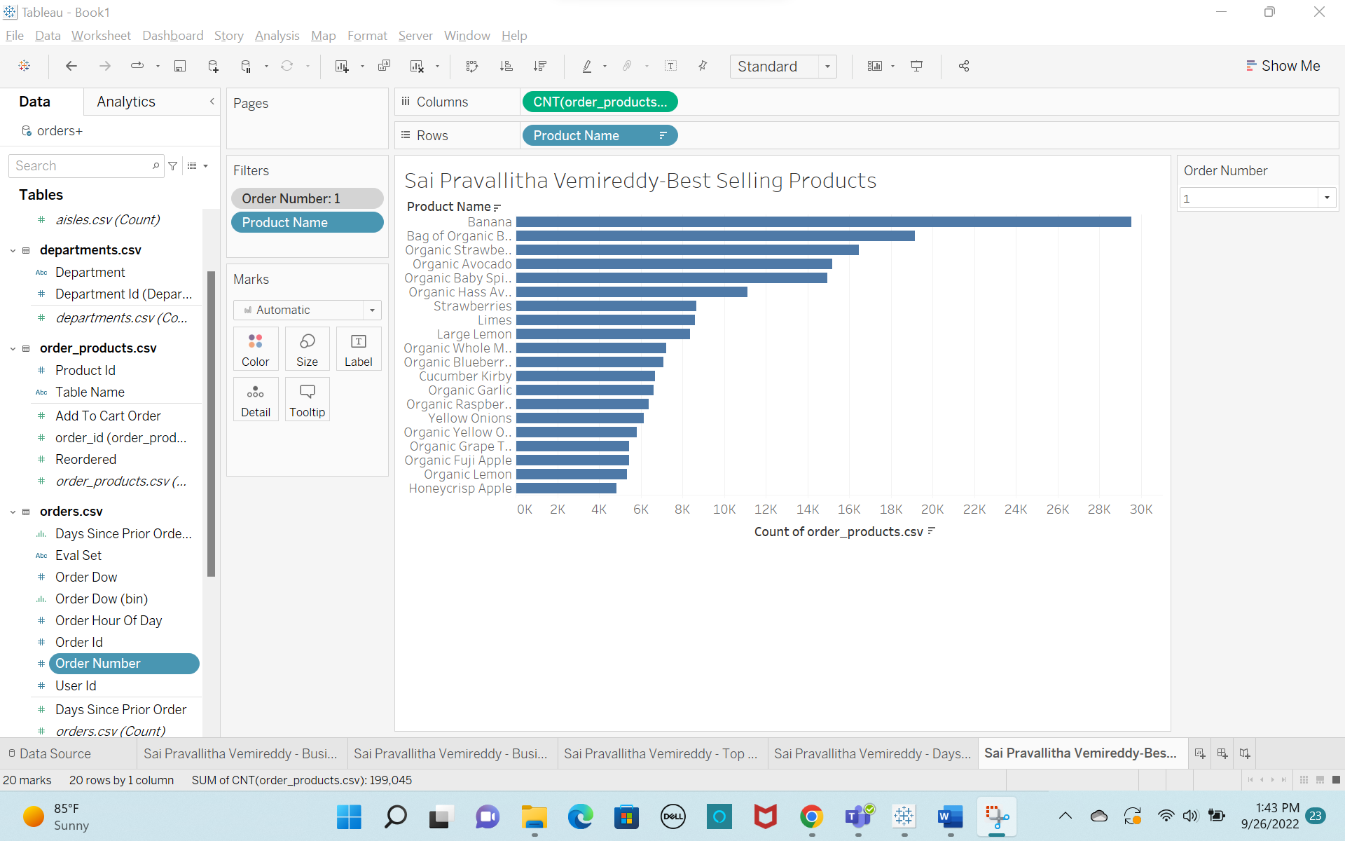

**c)**

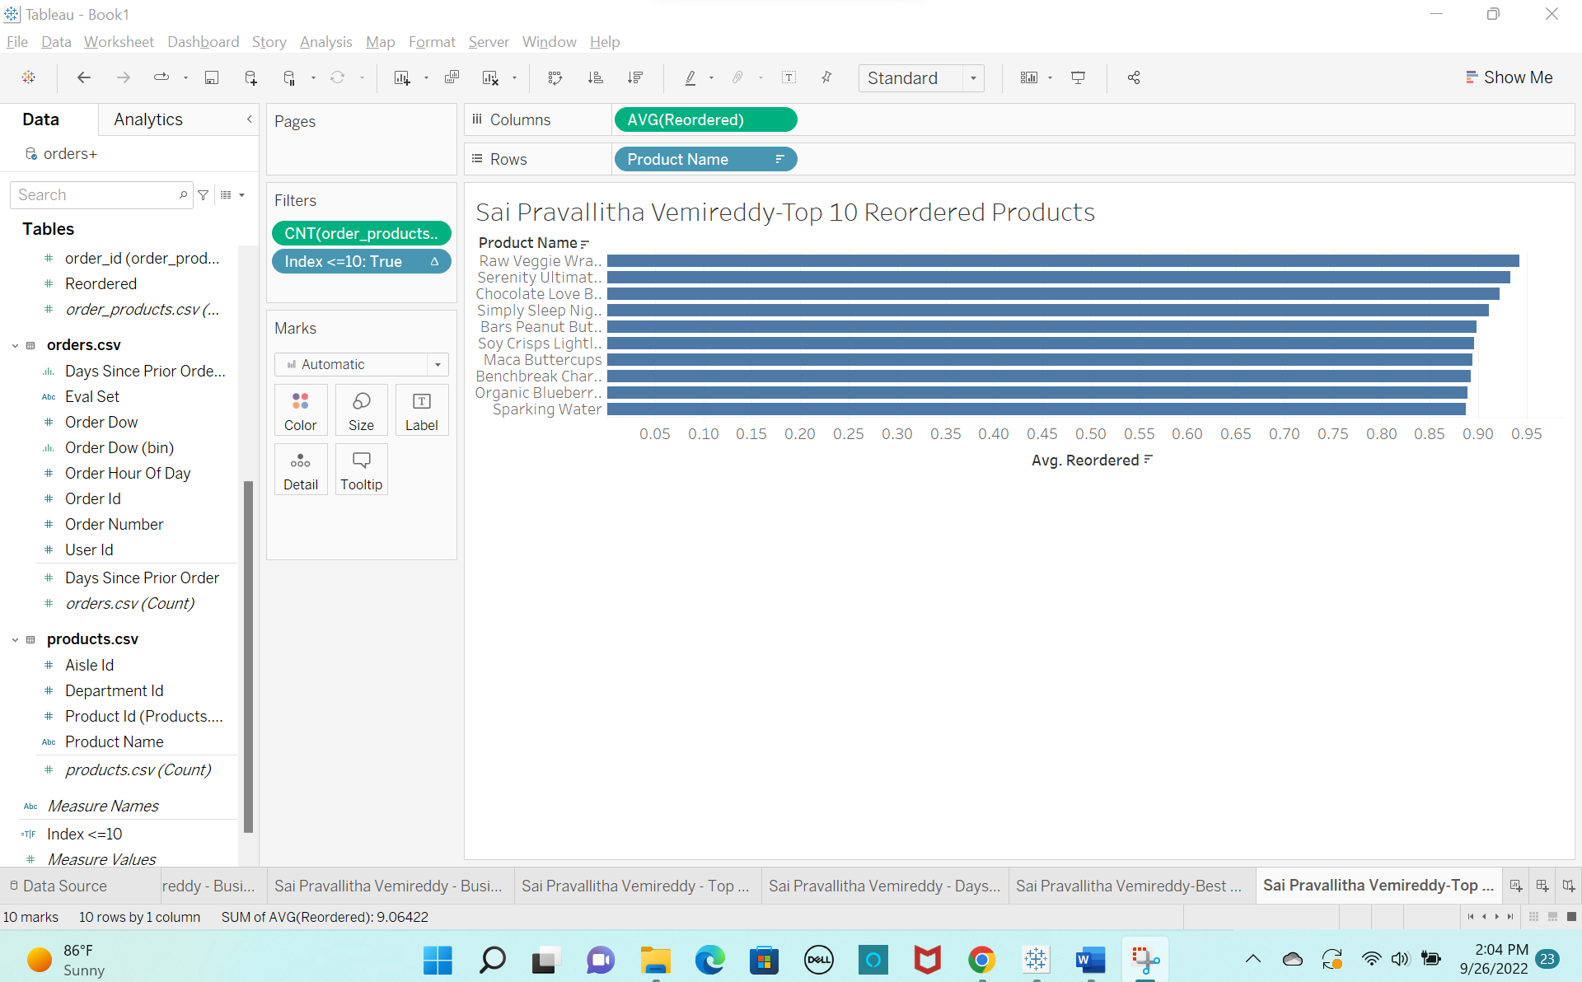

**Question 6:**

Most reordered product is Raw Veggie Wrappers, with probability of 0.94203

**d)**

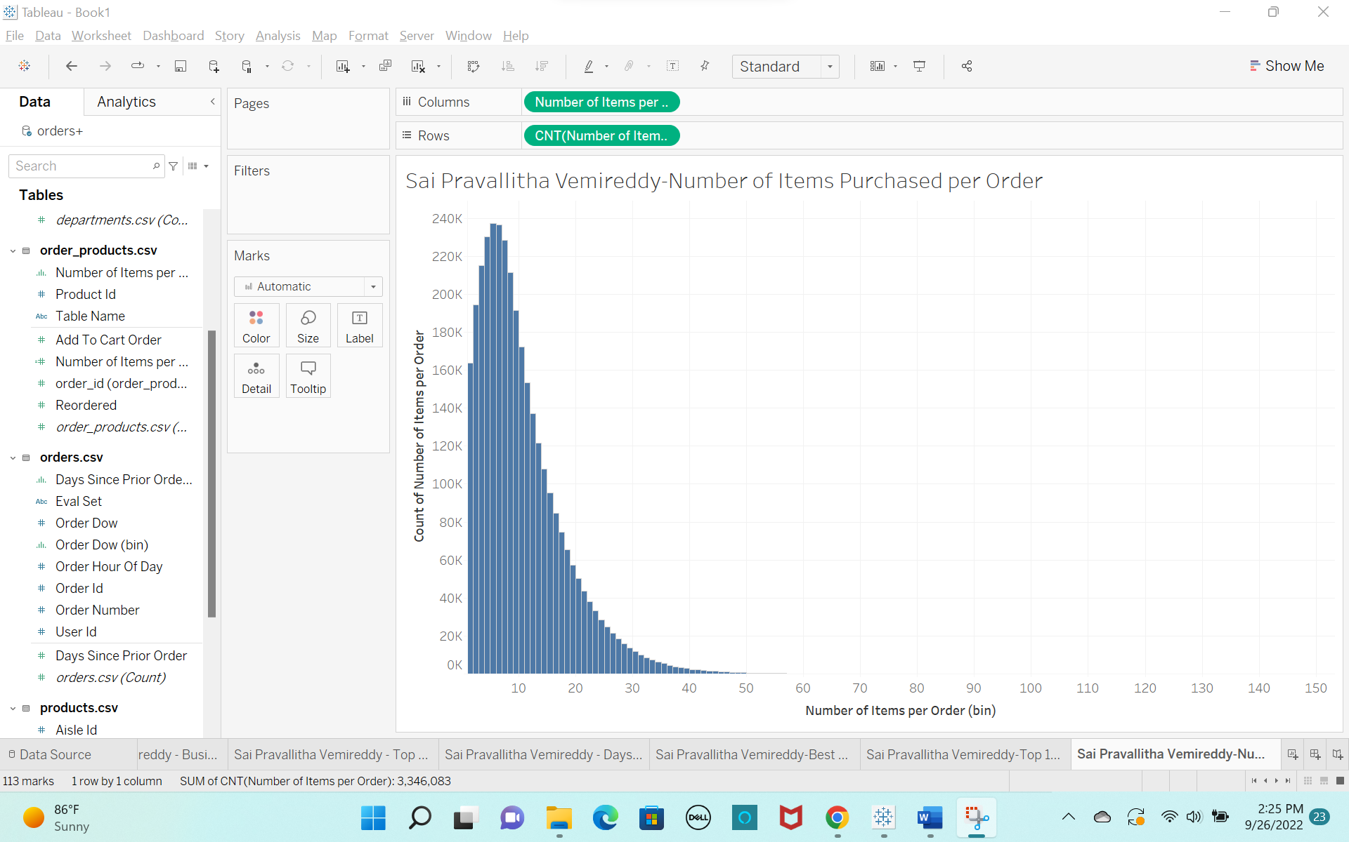

**Question 7:**

Customers most often order: 5 items per order

**3. Category Analysis:**

**a)**

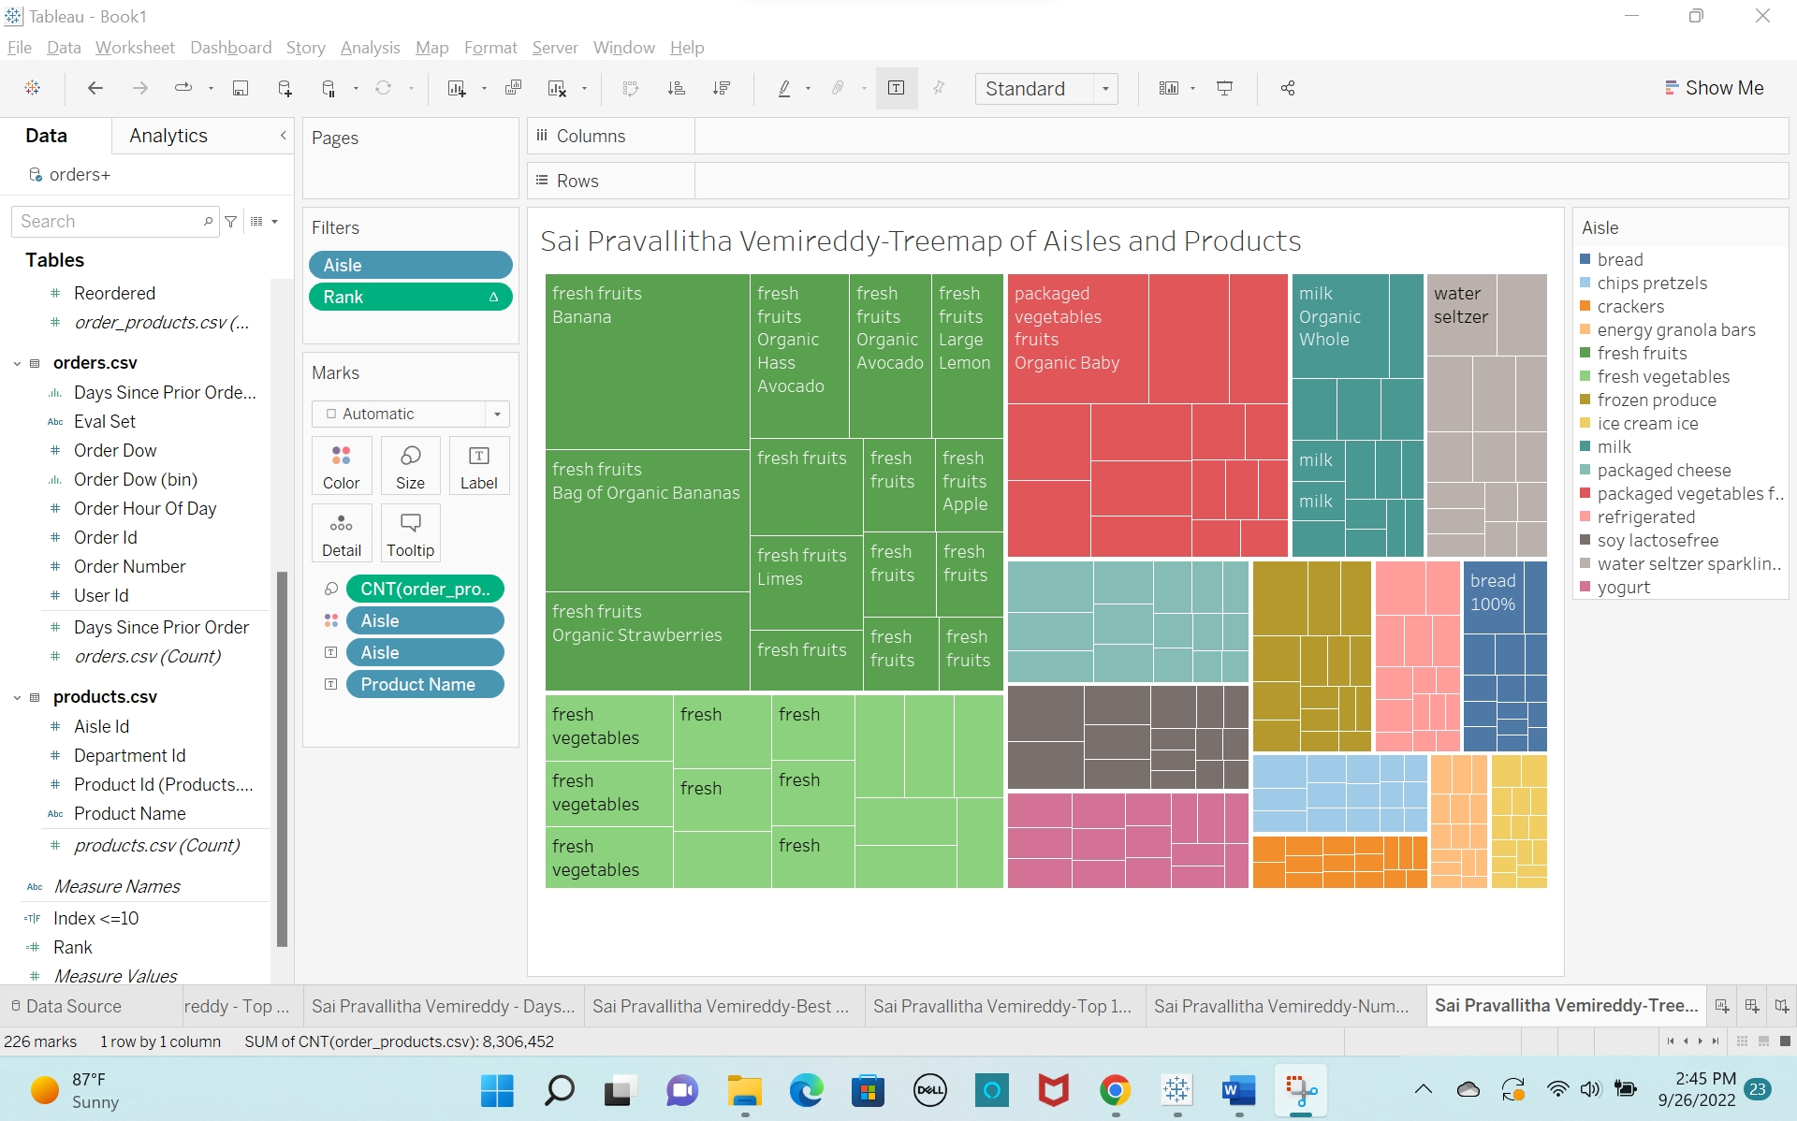

**Question 8:**

Top 3 Aisles that customers mostly order are:

1. fresh fruits

2. fresh vegetables

3. packaged vegetables fruits

**b)**

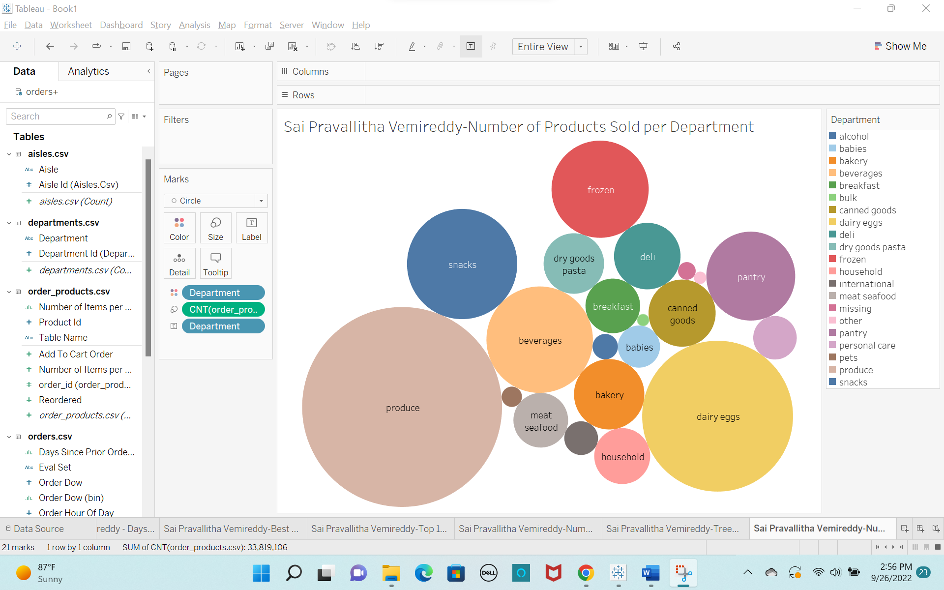

**Question 9:**

Top 2 departments with highest number of products sold are:

1. produce

2. dairy eggs

**5. Top Products:**

**a)**

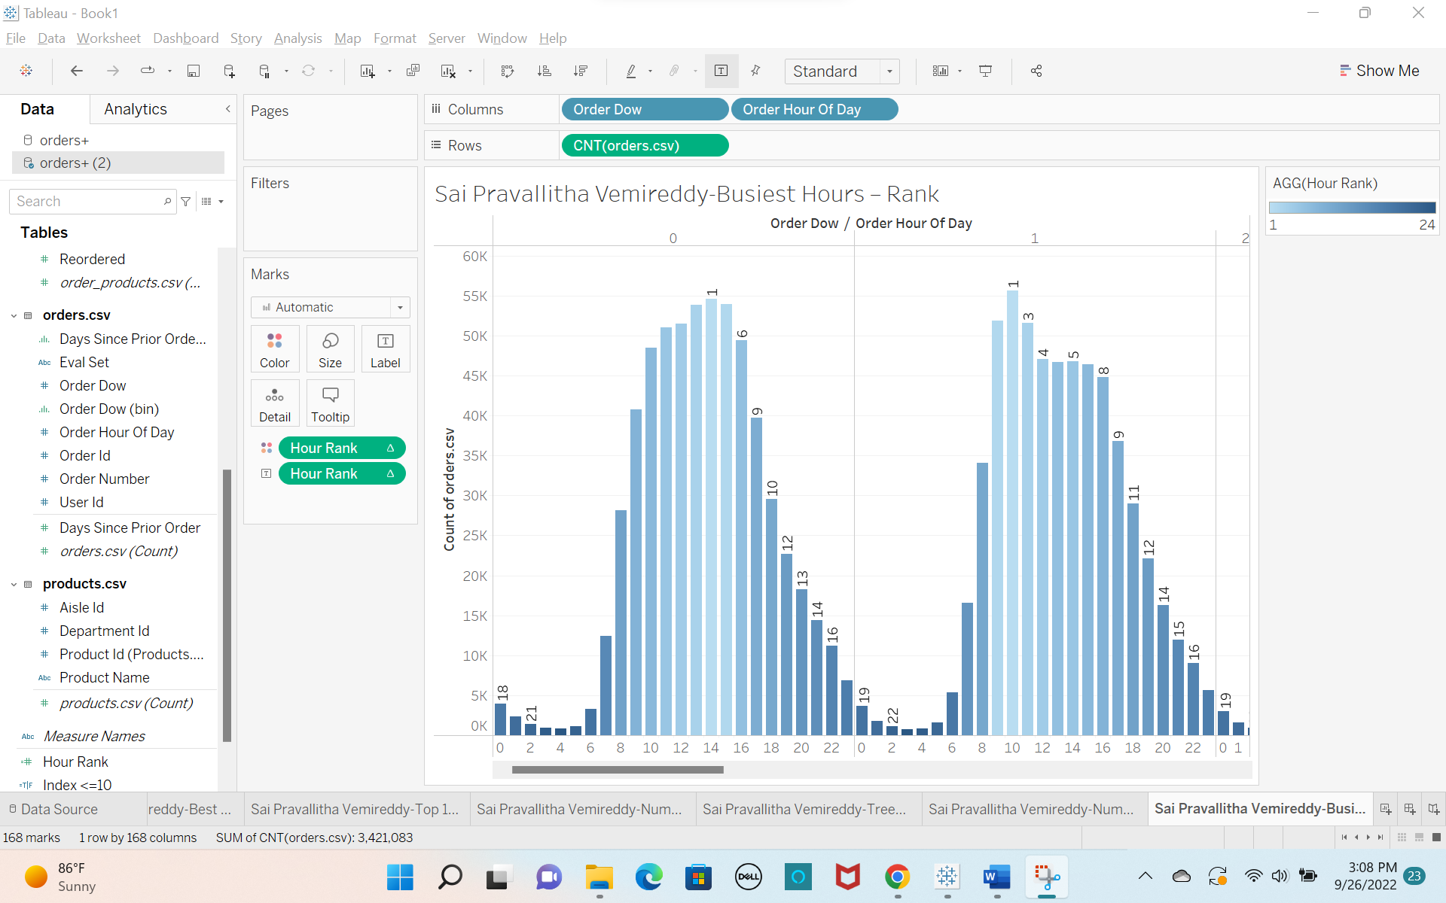

**b)**

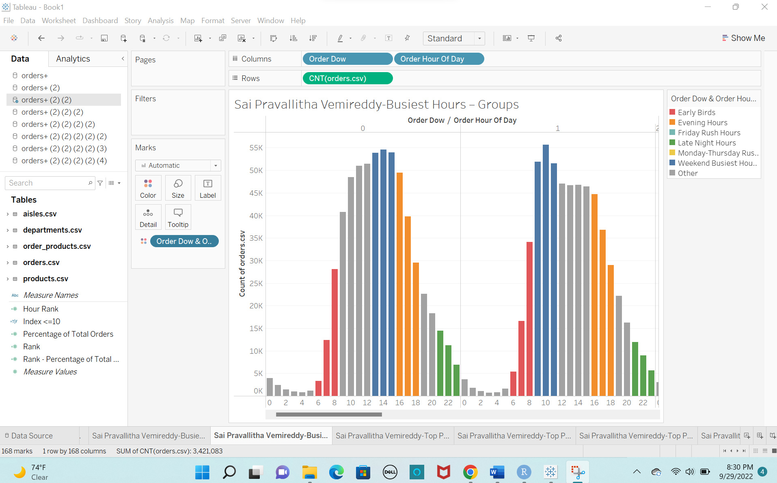

**c)**

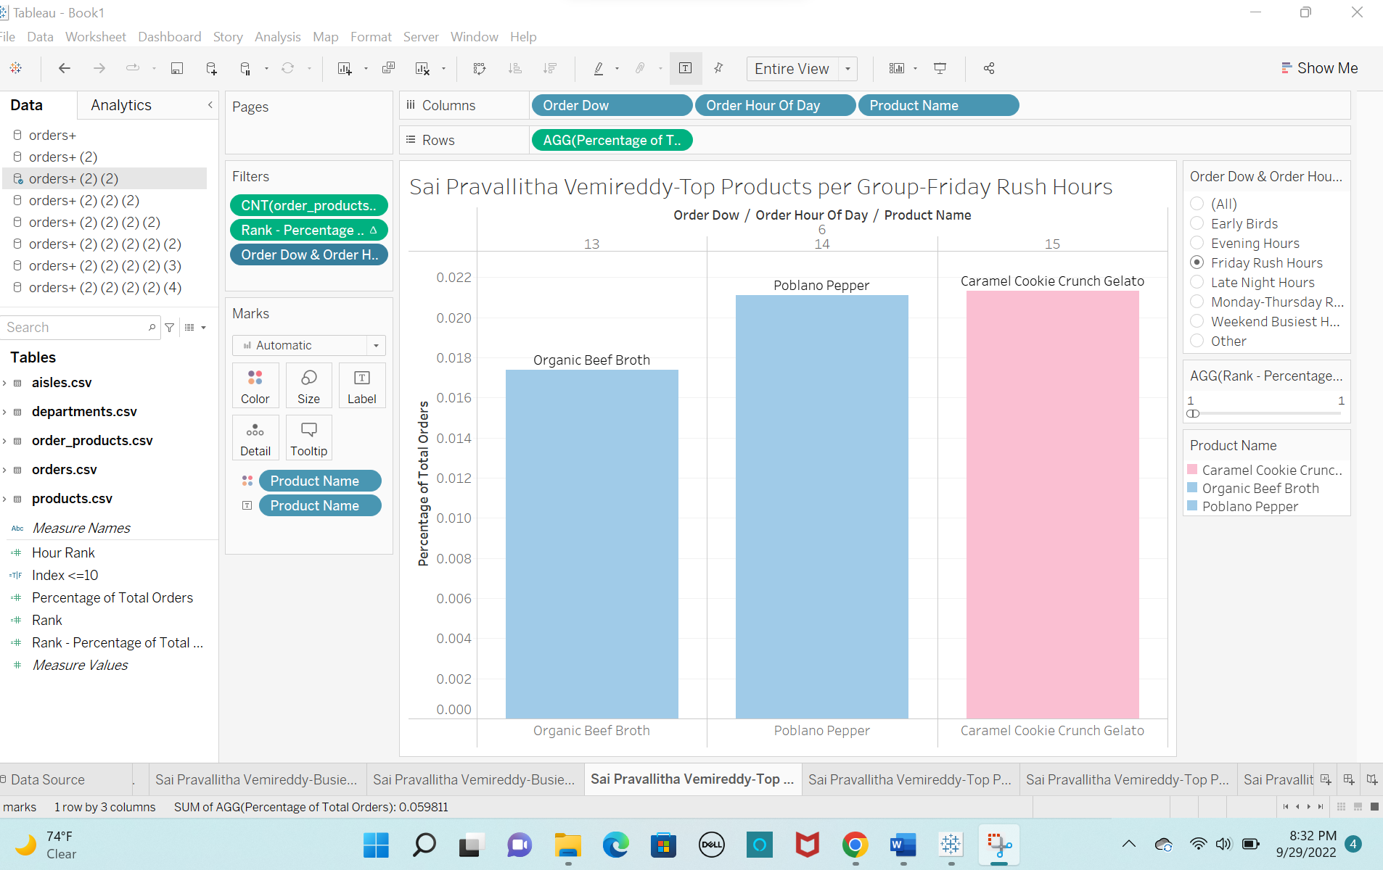

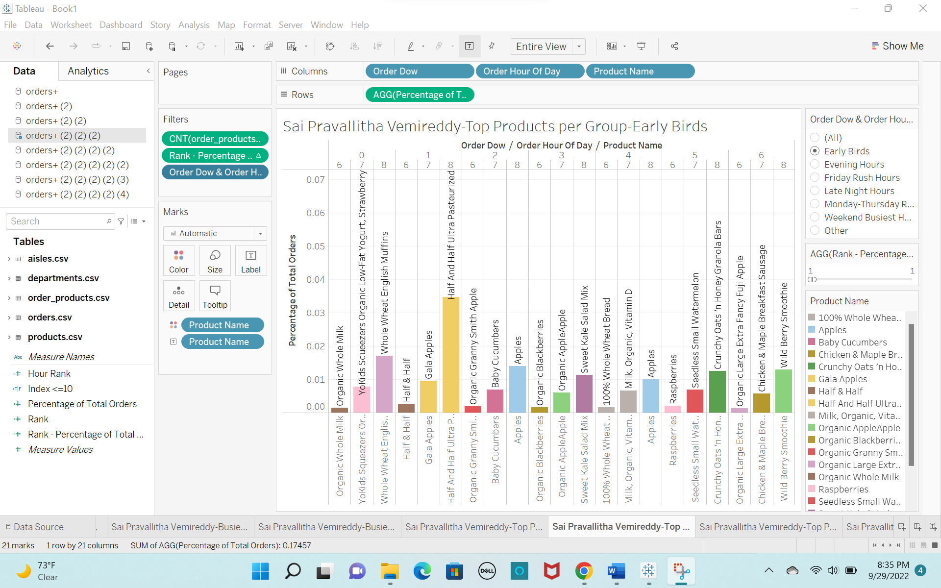

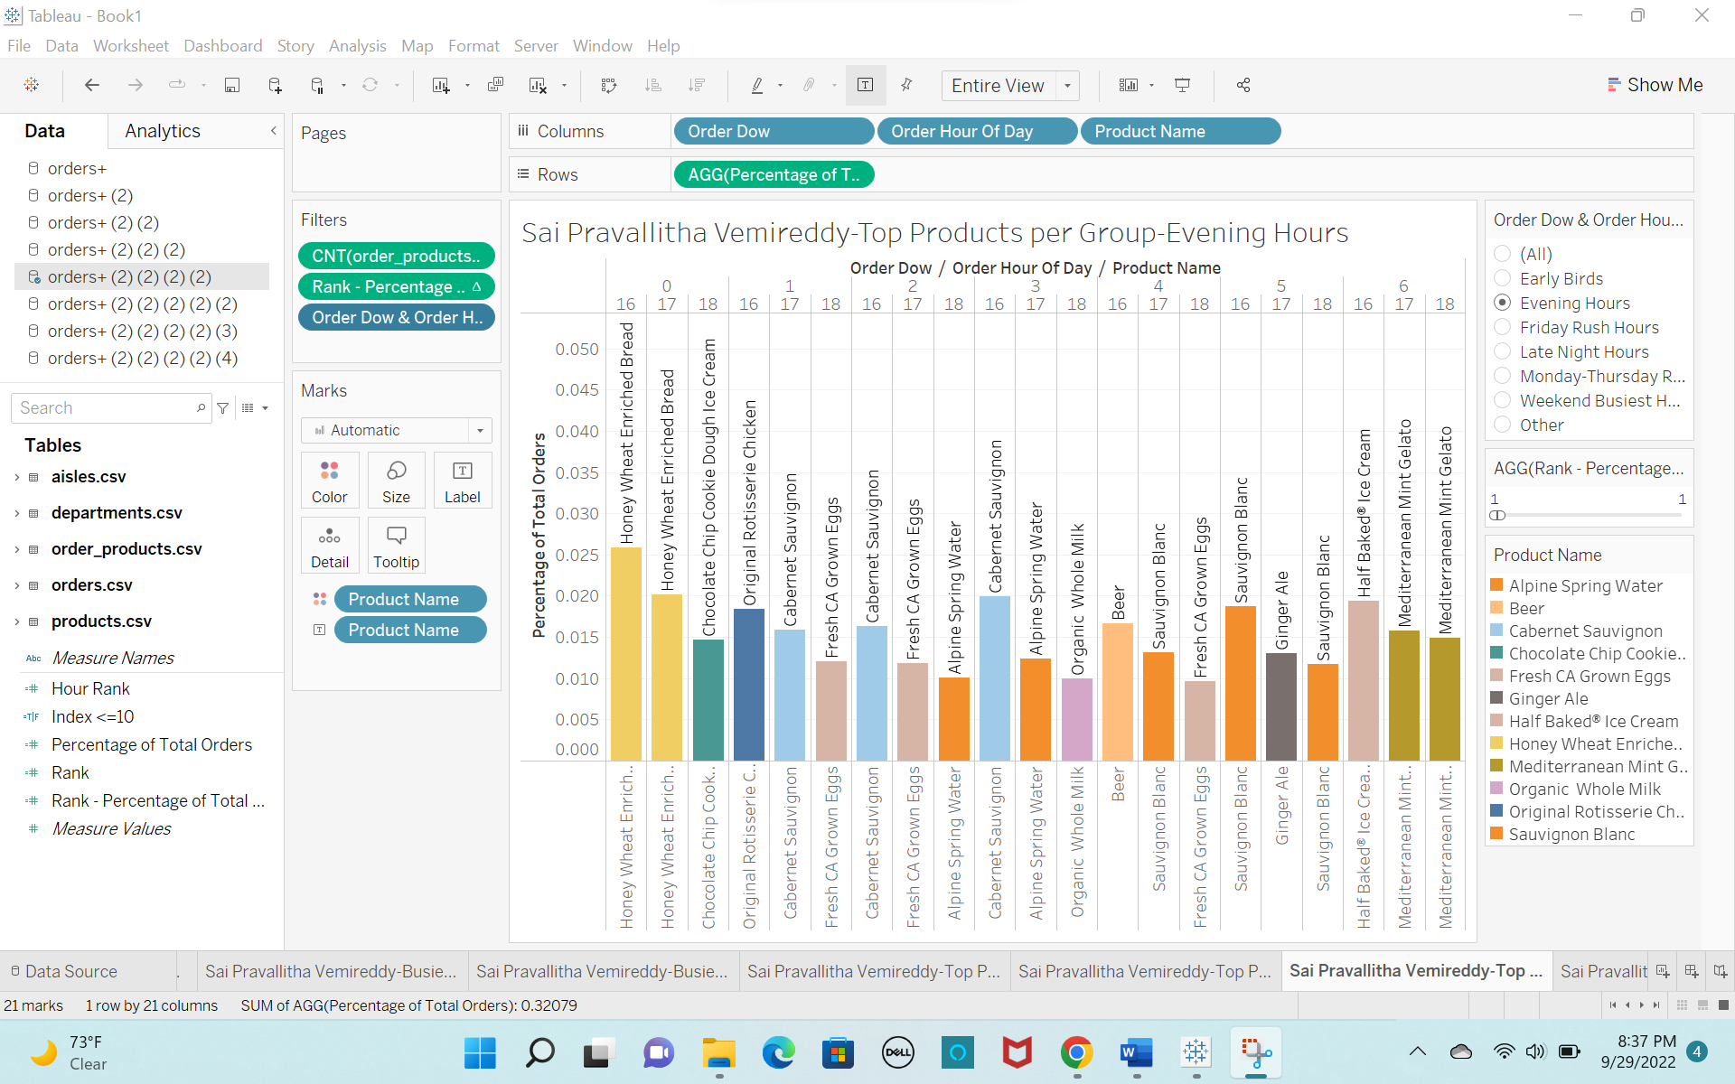

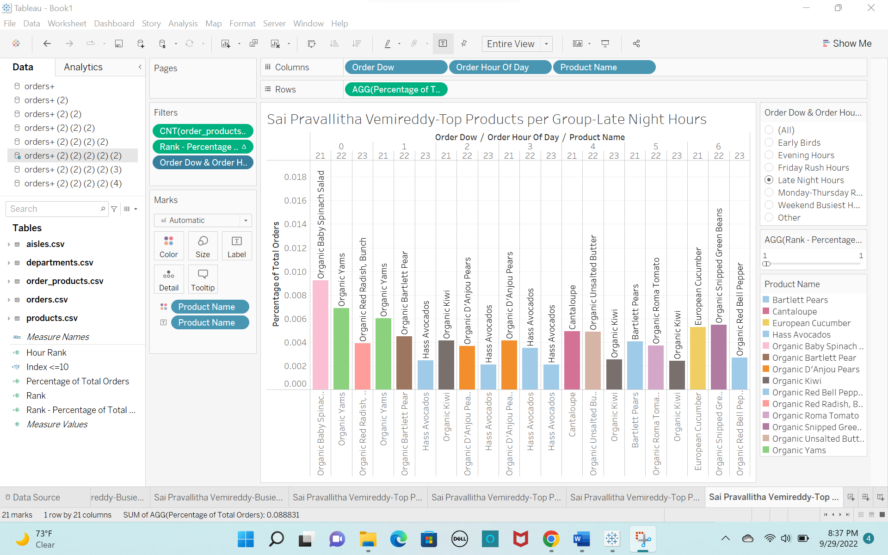

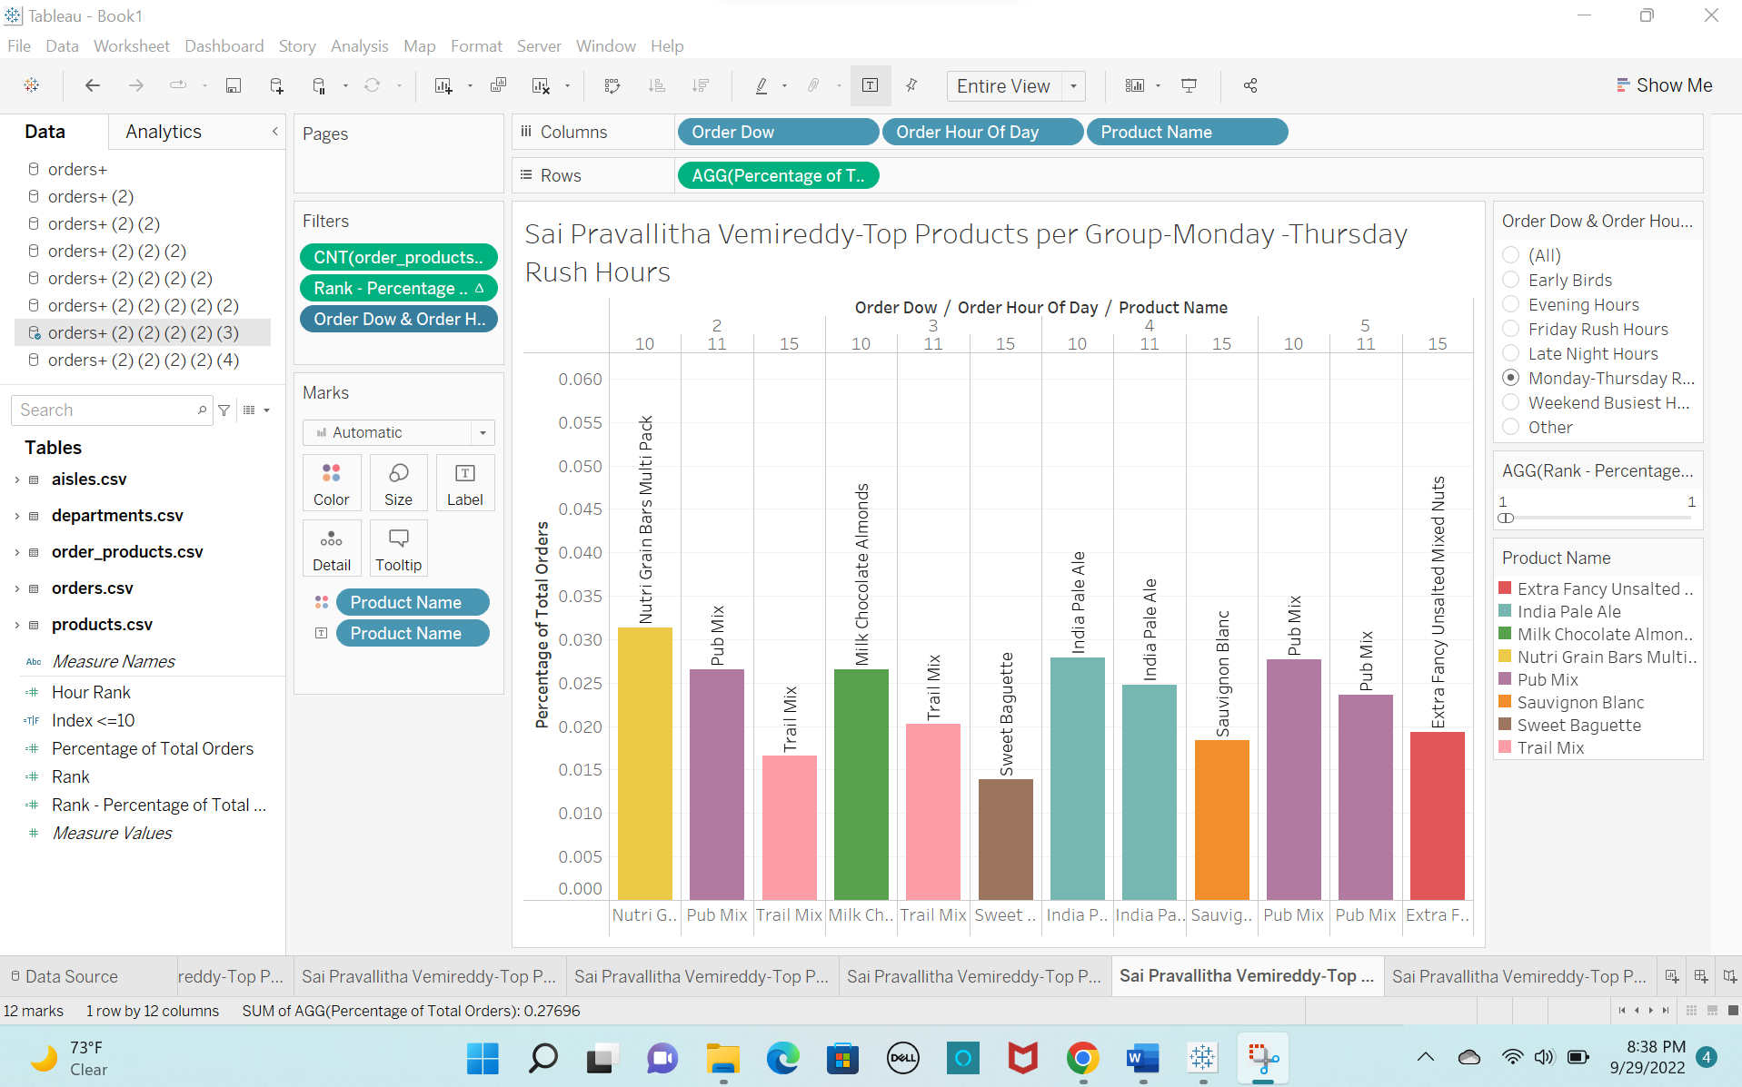

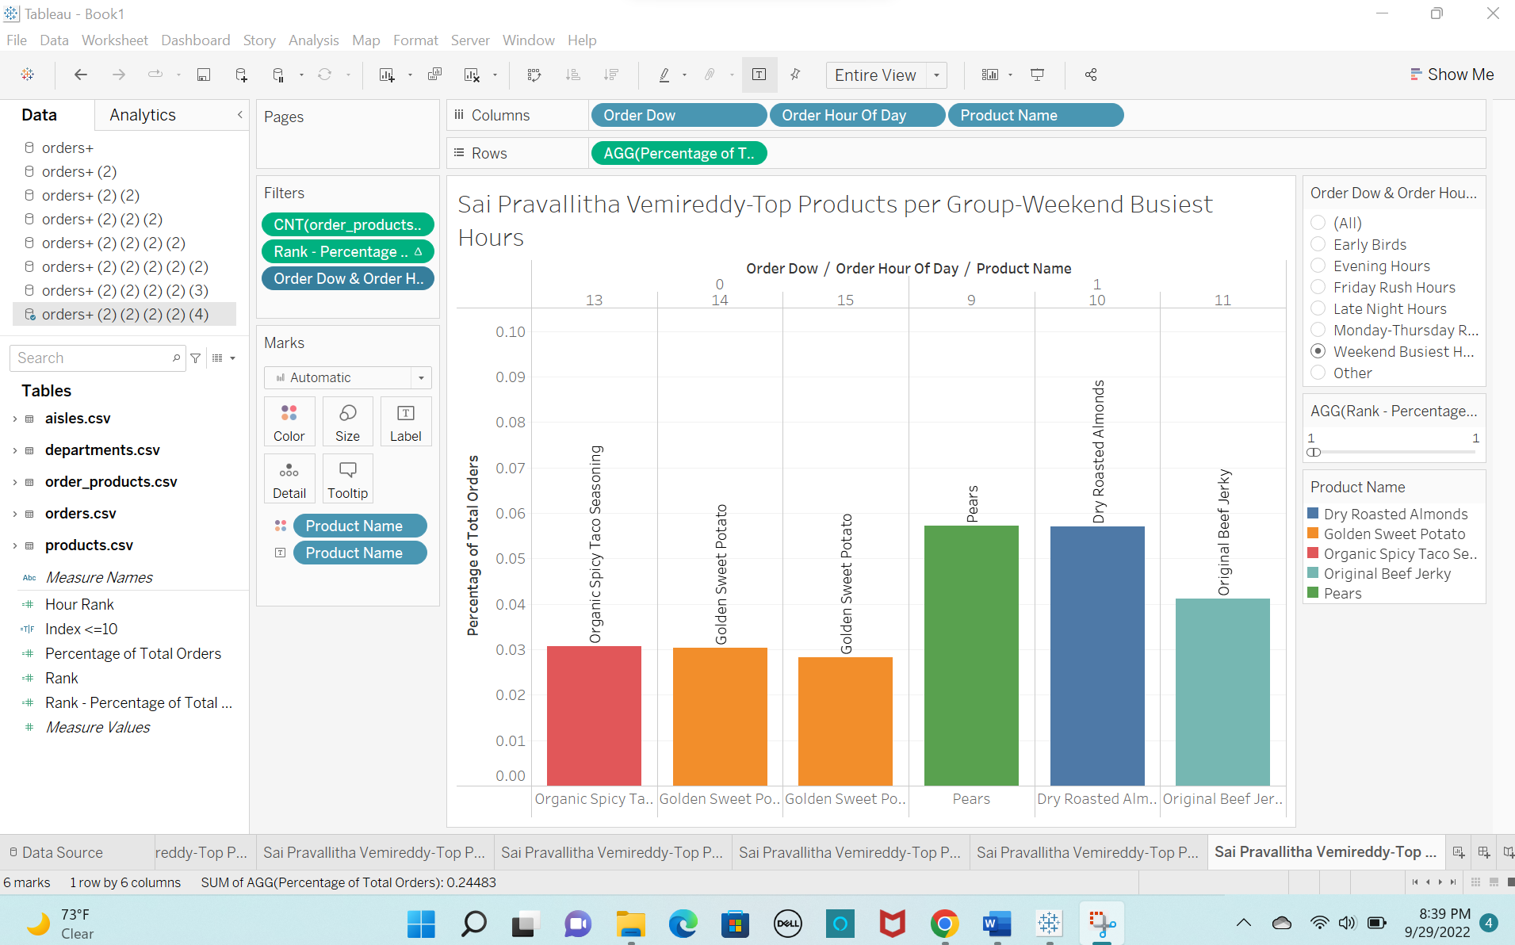

**Section 5: Organizing the Storyline with Storyboarding**

**Image of storyboarding process:**

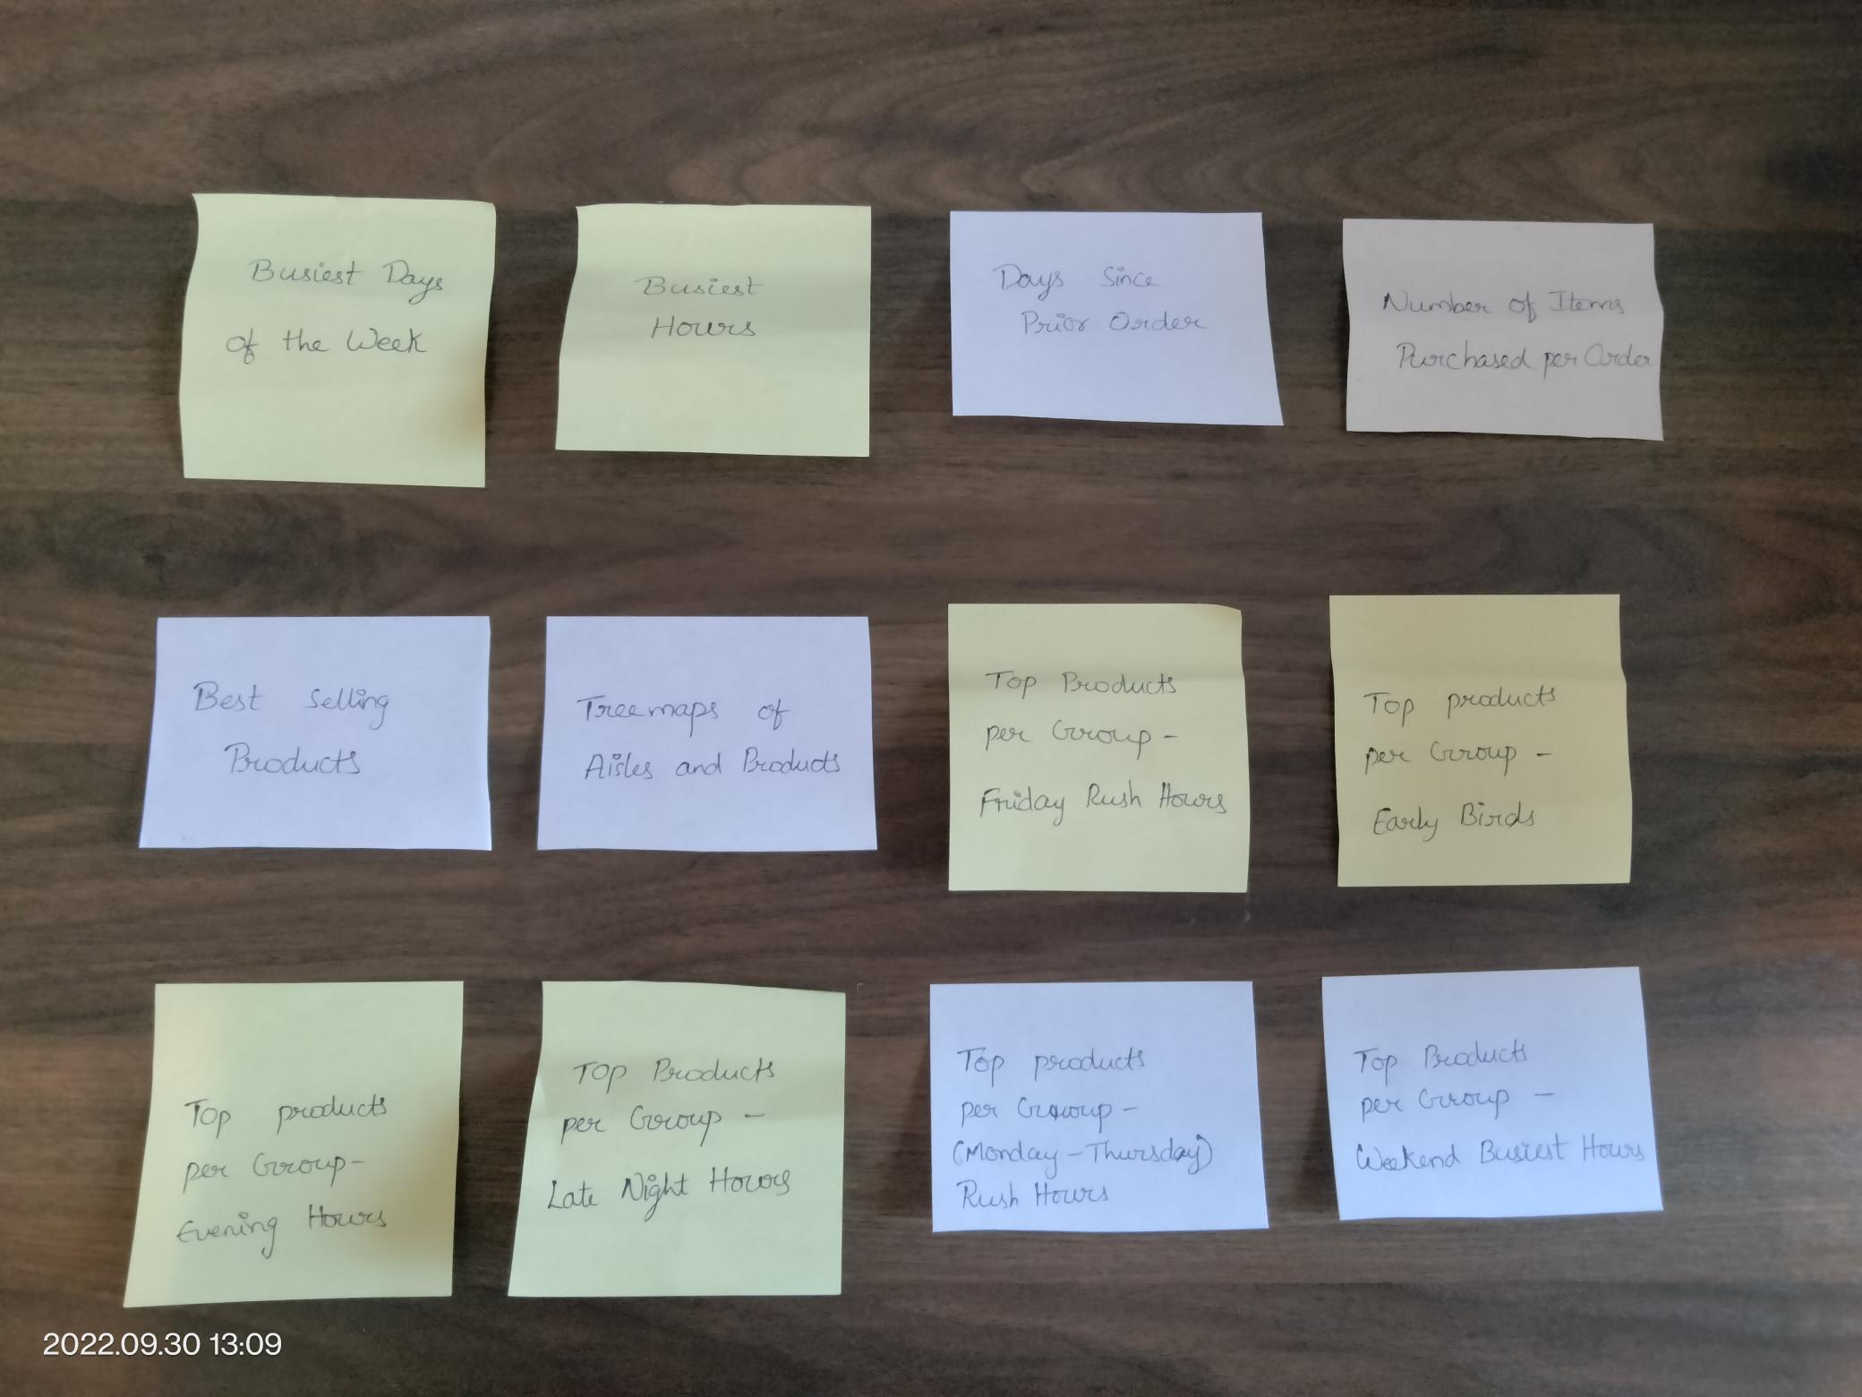

**My approach regarding storyline and sequence of story points is mentioned below:**

Freytag’s Pyramid

1. Busiest Days of the Week – Beginning
2. Busiest Hours – Rising Action
3. Days Since Prior Order – Rising Action
4. Number of Items Purchased per order – Climax
5. Best Selling Products – Falling Action
6. Tree maps of Aisles and Products – Falling Action
7. Top Products Per Group (total 6 groups) – Resolution

**Section 6:**

According to me, Logical Rhetoric is best suitable scenario for this story. Because using new promotional program helps to reduce the time between grocery orders.

**Screenshots of all the captions:**

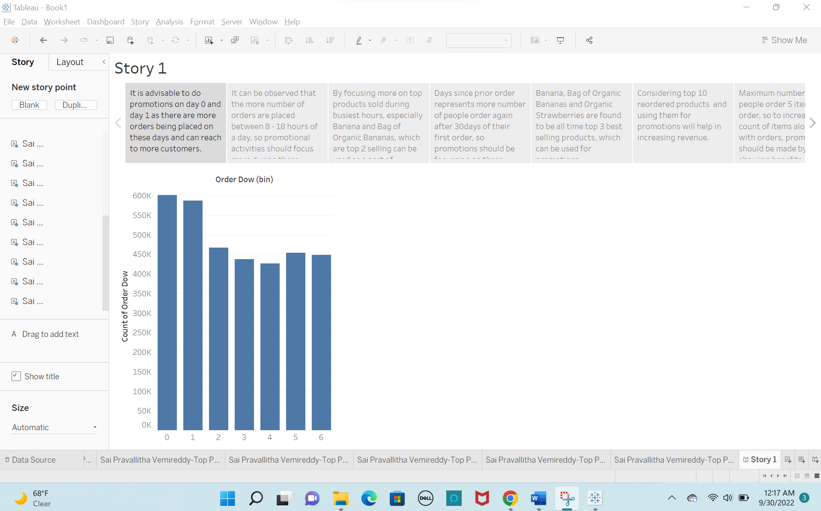

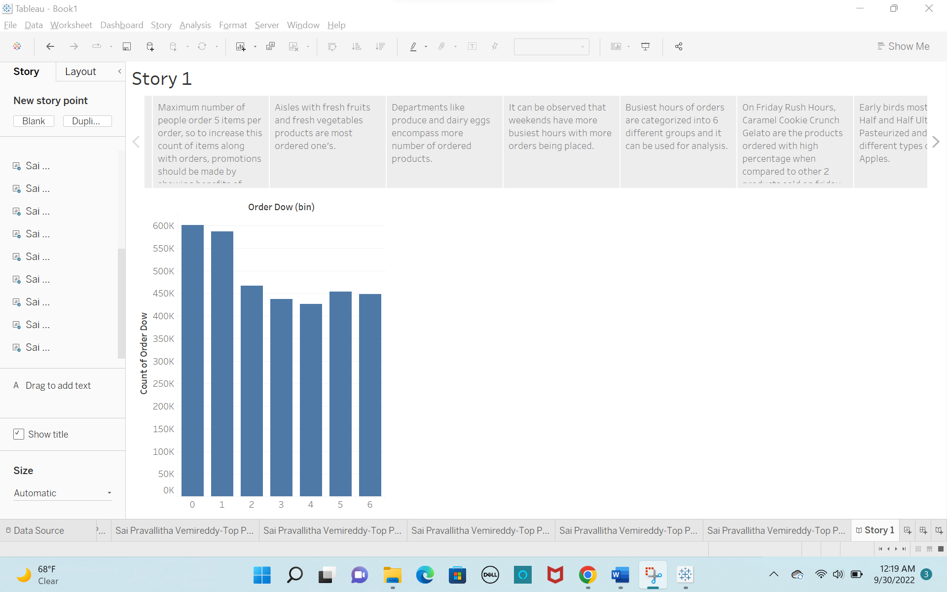

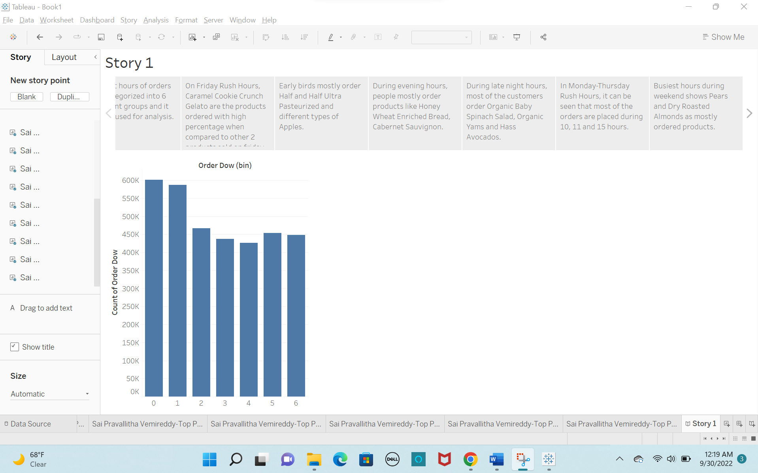

**Section 7:**

**Story Format Settings:**

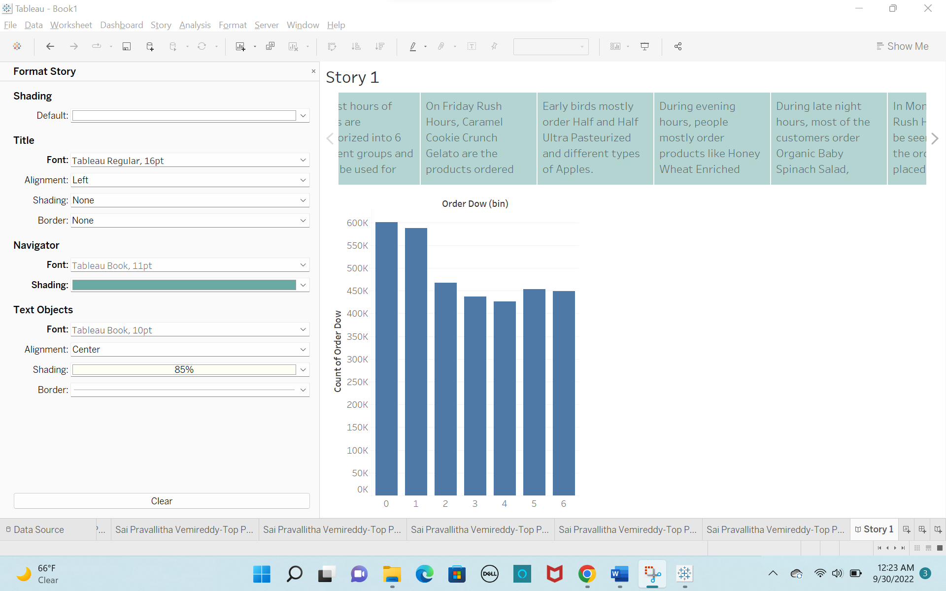

**First view of story with data source text box:**

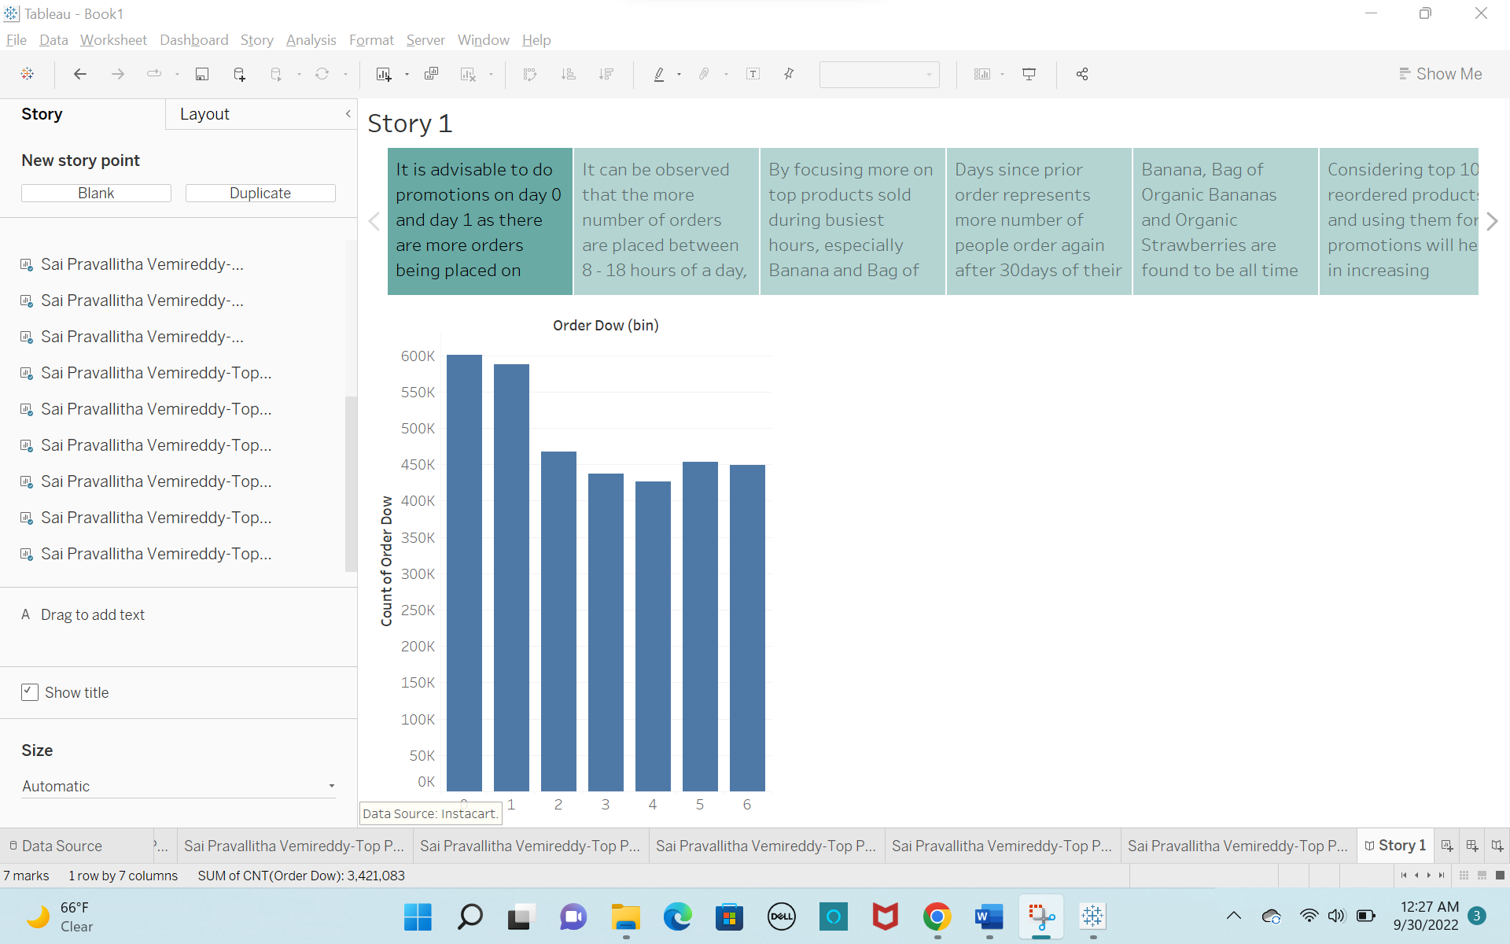

**The first view in my story with edited Titles and Axis Titles:**

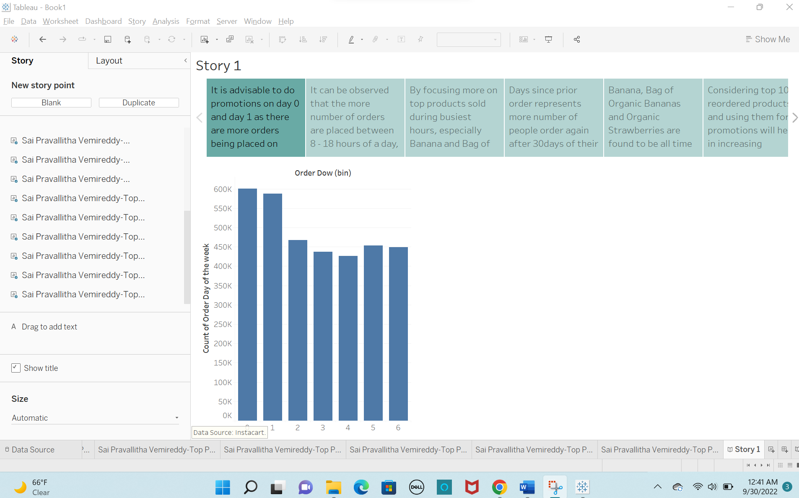

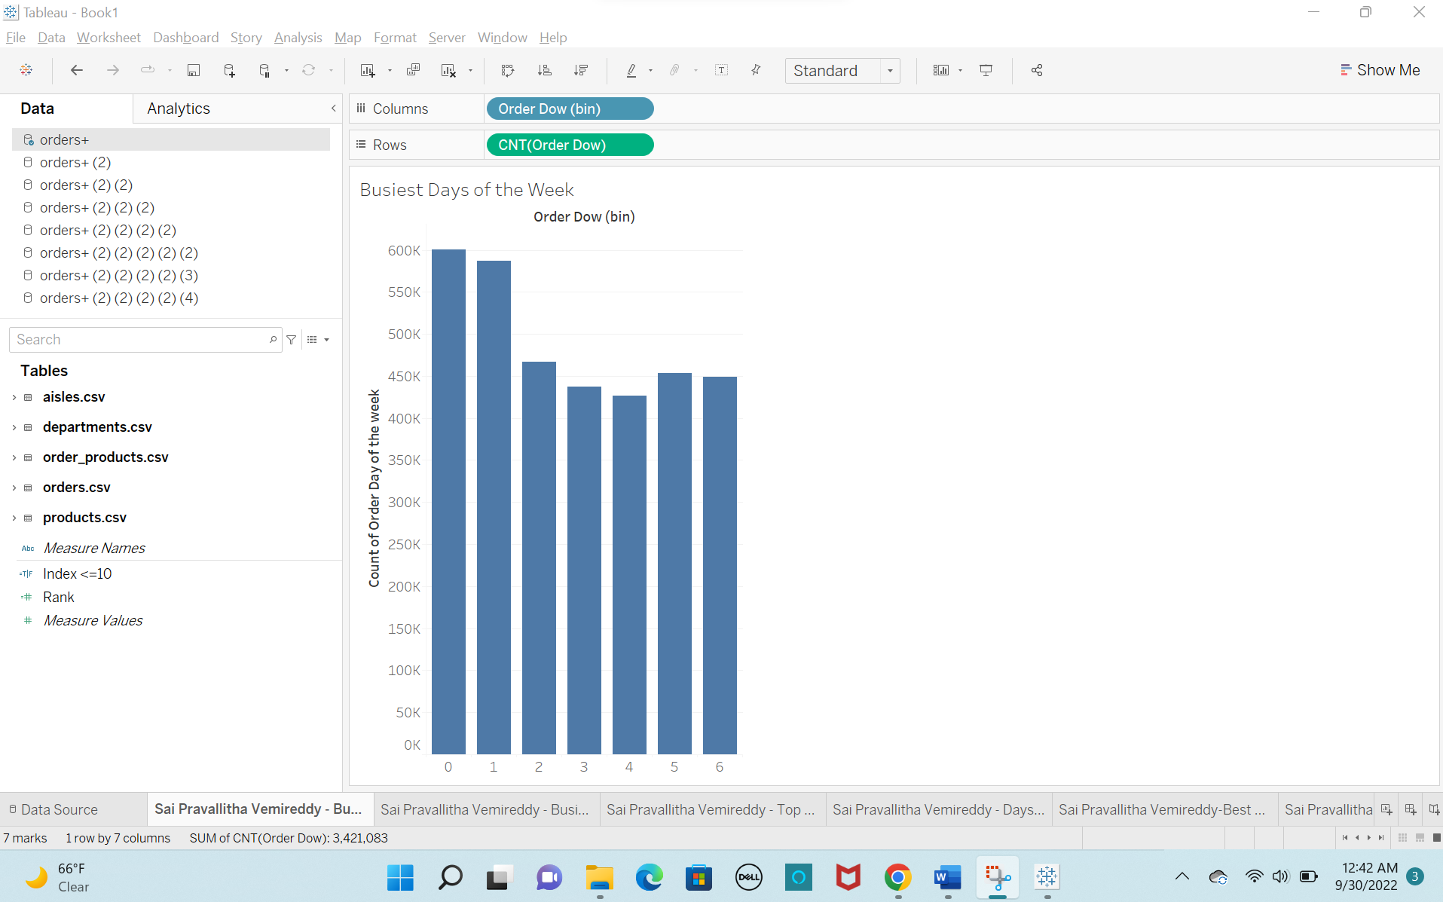

**The last view in my story with edited Titles and Axis Titles:**

